

# GRADE APPEAL

**General Information:**

The grade appeal process for any course is limited to issues related to grading fairness by the course instructor. A student may appeal a grade when the student believes a) instructor has departed from the standards set out in the course syllabus without a rational academic reason, and/ or b) an error was made in calculating the grade including failure to factor an assignment, quiz, exam or project. Issues that do not meet these criteria are not appropriate for a grade appeal.

Questions? email: ([academic-sc@nnmc.edu](mailto:academic-sc@nnmc.edu))

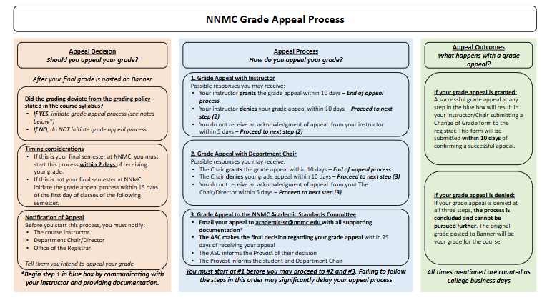

**\*SUPPORTING DOCUMENTATION**

The supporting documentation should be provided by the student. The list of possible supporting documentation will depend on the particular case. Here is a non exhaustive list that a student can submit

a) Course syllabus and grading policy. b) Specific assignment instructions/ rubrics/corresponding feedback from the instructor

c) Relevant written/digital communications with the Instructor (provide complete record of communication and not selected portions)

d) Digital copies of specific exams/ assignments and the corresponding grades in question (if available)

# GRADE APPEAL FORM

**Grade Appeal Information:**

| **Course Subject & Catalog Number** | **CRN** | **Course Title** | **Semester & Year** | **Department.**  **(Math, Business, BCES, Nursing.etc)** |
| --- | --- | --- | --- | --- |
|  |  |  |  |  |

Instructor’s name:

# Student Information:

Full Name ID

Home Address

Email: Phone

Student Signature Date

Step 1) Grade Appeal with Instructor

Instructor’s Signature Date

Instructor’s Decision: (check one) Grant Deny the Appeal

Step 2) Grade Appeal with Chair

Chair’s Decision: (check one)  Grant  Deny the Appeal

Chair’s Signature Date

Step 3)

# Grade Appeal Academic Standards Committee Decision:

(check one) Grant the Appeal  Deny the Appeal Academic Standards Committee Chair

Signature Date